

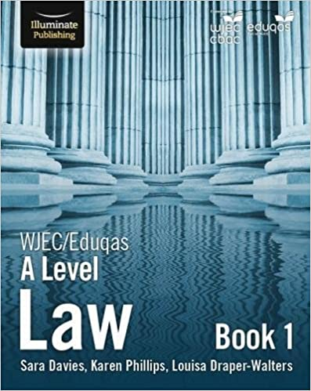

**A Level Law**



This is the latest version of the textbook we would advise students to purchase.

**YOU MUST COMPLETE THE FOLLOWING TASKS BEFORE ATTENDING YOUR FIRST LESSON IN SEPTEMBER.**

**1. Introduction**

A level Law at sixth form gives students the chance to study new topics that have not been experienced at GCSE. We want to ensure that everybody who has chosen the subject has a good understanding of what is involved, we have therefore set you various tasks to complete. You need to complete this bridging work before starting sixth form in the summer

**Before the start of term you should:**

• Purchase writing pens (black or blue and one red/ green) and Highlighters (two is enough)

**1.Mooting** - is where students present oral arguments in a persuasive manner on a point of law in mock court proceedings. If you would like to know more about what mooting is then visit the following YouTube clips – What is Mooting?

<https://mooting.lawbore.net/home.html> <https://www.youtube.com/watch?v=RQAeoPuuU3k>

**Legal Work experience**

[https://www.bigvoicelondon.co.uk/studentrecruitmentbigvoicelondon?fbclid=IwAR0tvxVBo7YdDAs](https://www.bigvoicelondon.co.uk/studentrecruitmentbigvoicelondon?fbclid=IwAR0tvxVBo7YdDAs8VWp2yCQPmn7pz9WRJ0O2IZLHGv94JGlecbMkP5IC7eU)

[8VWp2yCQPmn7pz9WRJ0O2IZLHGv94JGlecbMkP5IC7eU](https://www.bigvoicelondon.co.uk/studentrecruitmentbigvoicelondon?fbclid=IwAR0tvxVBo7YdDAs8VWp2yCQPmn7pz9WRJ0O2IZLHGv94JGlecbMkP5IC7eU)

**Lawbore** is an open-accessed website that is a service developed by The City Law School, part of City University, London. The City Law School is one of London’s major law schools, offering a range of academic and professional courses. This website provides students with opportunities to blog lawyers, look at the different careers in law, commentary on a range of different legal areas, a collection of multi-media law tutorials and information on mooting. Check it out at <http://lawbore.net/> Student guide.

**Bridging Work**

**Task one – use the internet to research the answer to the following questions:**

Explain the difference between a rule and a law

Explain the differences between civil and criminal law

List the courts in the criminal court structure

List the courts in the civil court structure

**Task 2**

You will need to know the difference between Civil and Criminal Law as we cover both in the A

Level Law specification

**Enforcing the Law:**

Our law is described as **CIVIL or CRIMINAL.**

Civil Law affects disputes between individuals or groups.

Criminal Law means that the behaviour is accepted as wrong, damaging to the individuals or to society. Criminal law involves the police.

**Colour code the following to show if they are about Civil or Criminal Law:**

Heard in the High Court or the County Court.



Heard in the Magistrates’

Court or the Crown court



The Judge decides whether the case is proved or not.



The magistrates or a jury decide if a case is proved or not.

Cases must be proved

‘beyond all reasonable doubt’



Cases are proved on ‘the balance of probabilities’

The defendant is found

‘liable or not liable’



The defendant is found

‘guilty or not guilty’



If guilty you would pay compensation.

**Employment Tribunals:**

Should everything go wrong and you are unable to find a solution in the workplace, you can take your case to an employment tribunal. This is a special court dealing with employment issues. There will be three people who hear the case and decide on the fairest result. These are a legally qualified chair and two lay people. Both the employer and employee put their case or invite a lawyer to do it for them and then a verdict is reached. If the employee wins their case they will be compensated.

**Advantage/Disadvantage? -**Can you spot the good and bad points of tribunals here?

The cost of a trial is high, usually about £2,000 If an employee wins, he/she is often worse off; the average award is just £3,000.

Before the case goes to tribunal, there is an attempt to get both sides to reach agreement.

Forms to claim unfair dismissal are available from

Job Centres.

There is a lot of preparation and paper work required.

More than half the people who take their case to a tribunal end up in a worse paid job.

Orders are rarely made to give the employee their job back.

Of the two lay people on the panel, one will have experience from an employers’ point of view and one from an employees’

**Task 3 -** Case Studies

**You Be the Judge**

**Task**: go to: [http://ybtj.justice.gov.uk/. You will need sound as you](http://ybtj.justice.gov.uk/) are going to work through two cases, completing the questions below as you go. **Burglary & Harassment**

Please note: there are other cases you can have a look at, but these two you must complete for this task!

**Defendant One: Alexander Jackson**



What did he do?

What was the plea?

Which court was it heard in and why?

Who determines sentencing for the defendant?

**Relevant information from the police officer:**

**Relevant information from the Victim:**

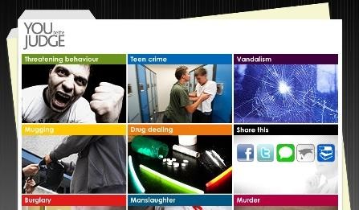

Will the fact that the victims were at home at the time of the break-in affect your sentence?

**Yes Not sure No**



Judge’s response:

Do you think the fact that an item of sentimental value was taken is significant?

**Yes Not sure No**



Judge’s response:

**Mitigating Factors Aggravating factors**

Would a genuine commitment from Alex to come off drugs affect your sentence?

**Yes Not sure No**



Judge’s response:

What other circumstances might be relevant in sentencing:

**Sentence choices:**

1. Prison: 2.5 years ( ½ in custody + ½ monitored in the community )

2. Prison: 3.5 years ( ½ in custody + ½ monitored in the community )

3. Prison: 4.5 years ( ½ in custody + ½ monitored in the community )

4. Prison: 6 years ( ½ in custody + ½ monitored in the community )

I would chose option because…

He was actually given option because…

What is the **purpose** of sentencing Alex? *Link to the aims of sentencing – which do you think was uppermost in the judge’s mind*

**Defendant Two: Chris Williams**

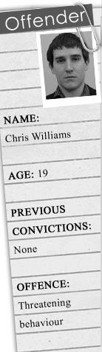

What did he do?

What was the plea?

Which court was it heard in?

**What is the relevant evidence from the victim?**

**Relevant information from the defendant?**

Will the fact that Mrs Dixon is elderly influence your sentence?

**Yes Not sure No**



Judge’s response:

Do you think the fact that Chris was provoked is significant?

**Yes Not sure No**



Judge’s response:

**Mitigating Factors Aggravating factors**

Will the fact that Chris pleaded guilty from the start affect your sentence?

**Yes Not sure No**



Judge’s response:

**Sentence choices:**

1. Fine: £300

2. Community sentence: 80 hours unpaid work + £100 compensation + £90 costs

3. Community sentence: 200 hours unpaid work + weekly supervision meetings with a probation officer for 2 years

4. Prison: up to 3 months ( ½ in custody + ½ monitored in the community )

I would chose option because…

He was actually given option because…

What is the **purpose** of sentencing Alex? *Link to the aims of sentencing – which do you think was*

*uppermost in the Magistrates’ mind.*

**Below are a range of documentaries and legally linked films…**In case you need them, the suggestions and their origins are below.

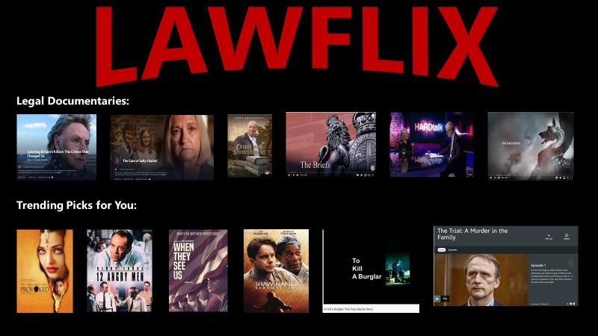

**Title Origin Link (if available)**

Catching Britain’s

Killers

The Case of

Sally Challen

iPlayer (BBC) [https://www.bbc.co.uk/iplayer/episode/m0009dz2/catching](https://www.bbc.co.uk/iplayer/episode/m0009dz2/catching-britains-killers-the-crimes-that-changed-us-series-1-2-double-jeopardy)- [britains-killers-the-crimes-that-changed-us-series-1-2-](https://www.bbc.co.uk/iplayer/episode/m0009dz2/catching-britains-killers-the-crimes-that-changed-us-series-1-2-double-jeopardy) [double-jeopardy](https://www.bbc.co.uk/iplayer/episode/m0009dz2/catching-britains-killers-the-crimes-that-changed-us-series-1-2-double-jeopardy)

iPlayer (BBC) [https://www.bbc.co.uk/iplayer/episode/m000c65v/the](https://www.bbc.co.uk/iplayer/episode/m000c65v/the-case-of-sally-challen)- [case-of-sally-challen](https://www.bbc.co.uk/iplayer/episode/m000c65v/the-case-of-sally-challen)

Crime and Punishment (History of the Law)

YouTube <https://www.youtube.com/watch?v=kn1gdZMLtrk>

The Briefs YouTube <https://www.youtube.com/watch?v=QWTcg8Ye6fI>

HARDtalk interview with Lady Hale

YouTube <https://www.youtube.com/watch?v=i1VozJR_jC8&t=414s>

The Bar YouTube [https://www.youtube.com/watch?v=6d78ROXCPg](https://www.youtube.com/watch?v=6d78ROXCPgI)I

To Kill a Burglar YouTube [https://www.youtube.com/watch?v=BemcOAg53e](https://www.youtube.com/watch?v=BemcOAg53eM)M

The Trial: Murder in the Family

All4 [https://www.channel4.com/programmes/the-trial-a-murder-](https://www.channel4.com/programmes/the-trial-a-murder-in-the-family) [in-the-family](https://www.channel4.com/programmes/the-trial-a-murder-in-the-family)