YEAR 11
DRAMA REVISION

Section A: Multiple Choice

Section B: Noughts and Crosses

Section C: Theatre Review

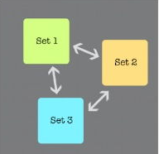
Section A: Multiple Choice
1. Circle the correct name for this stage
a) End on
b) Proscenium Arch
d) Promenade

2. Who is responsible for instructing the actors?
a) Director
b) Playwright
c) Theatre Manager

3. Who is responsible for learning a part in case they need to take over a role for someone?
a) Director
b) Playwright
c) Understudy

4. Who is responsible for designing the lighting og the stage.
a) Director
b) Lighting Designer
c) Theatre Manager

5. Who is responsible for running the backstage area, supervising crew, keeping lists of props and rehearsal schedule.
a) Director
b) Playwright
c) Stage Manger

6. When using a Proscenium Arch stage, which of the following is correct?

a) Actors always have to exit and enter through the audience
b) Audiences move around the set during the performance
c) Wings can help conceal actors and enable exits and entrances

7. Who is responsible for operating technical equipment such as lighting and sound boards during a performance.
a) Technician
b) Stage Manger
c) Theatre Manager

8. What stage can have large backdrops and scenery without blocking sightlines
a) Traverse
b) Theatre In the Round
c) Proscenium Arch

9. What stage type do the actors have to be most aware of their blocking to make sure no section of the audience misses important pieces of action?
a) Thrust
b) Theatre in the Round
c) End on

10. What is the stage positioning of the tree in Figure 2? would apply to promenade staging?
- Downstage centre
- Upstage left
- Upstage right
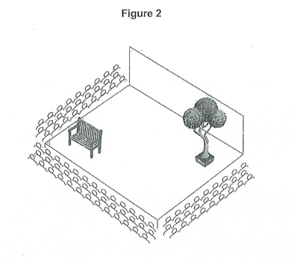

/10

Roles and Responsibilities in the Theatre

- Director – Responsible for the overall creative vision of the show.

- Performer – An actor, singer or dancer whose job is to perform within a production.

- Set designer – Responsible for designing the set.

- Costume designer – Responsible for designing the costume, hair and make-up for a production.

- Lighting designer – Responsible for designing the lighting.

- Sound designer – Responsible for designing the use of sound e.g. sound effects or music.

- Stage manager – Responsible for backstage during a production.

- Technician – Involved in rigging the lighting, sound equipment and set. They may also operate the technical equipment during a show.

- Theatre manager – Responsible for the front of house team and is usually a permanent employee of the theatre building.

- Understudy – A performer who learns the lines and blocking of a regular performer so that they can cover a part in the production if necessary.

Stage Configurations in the Theatre

End on stage
Thrust stage

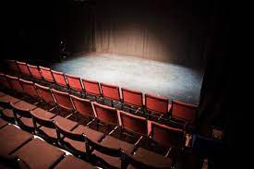
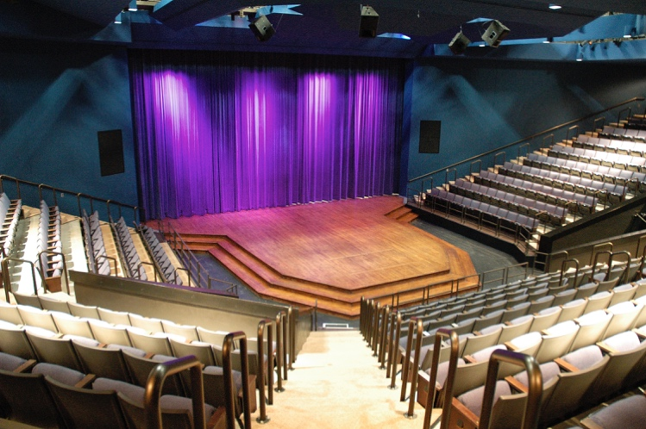

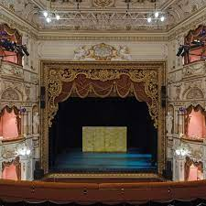
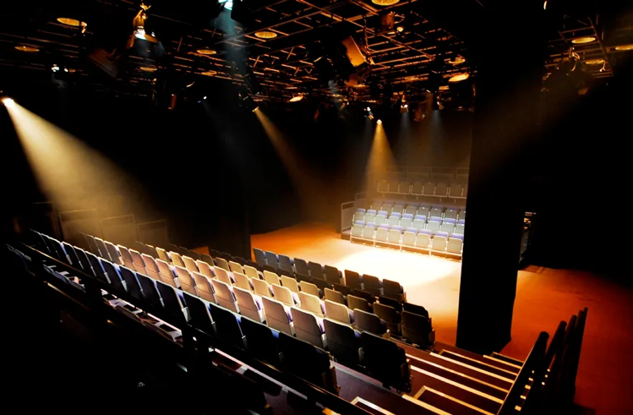
Proscenium arch stage
Traverse stage

Theatre in the round stage
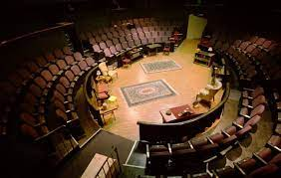

Revision Pack Section B Noughts and Crosses

Section B – Noughts and Crosses ( 44 marks)

9.1 Design questions (4 marks) - Set or costume
4 design elements – detailed description to fit dystopian theatre style
9.2 Line of dialogue (8 marks)
Break line into 4 parts
Describe how you would use your physical and vocal skills and explain impact x 4
9.3 Shaded part of the extract (12 marks)
Intro stating where the extract takes place and link to question
Break into 3 parts
Focus on what the questions asks – Describe and explain use of vocal, physical and spatial skills for you and the other actor x3
9.4 Interpretation of a character for extract and whole play (20 marks)
Intro – describe the character and your interpretation
Break into 4 parts
PEEEC x 4

4 marker key words mind map – Remember that the four marker could be about set design OR costume design. Also remember that what you write for costume design will be dependent on which character you are asked about.
Stained items of clothing (Callum)
100% wool fabric (Sephy)
Cashmere fabric (Sephy)
Scruffy hair (Callum)
Dystopian Theatre
Dirty white trainers (Callum)
Minimalistic
Polyester Cotton fabric (Callum)
Neat ponytail (Sephy)
Designer branded clothes (Sephy)
4 marker
(costume)
Blanket (for Callum and Sephy to sit on)
Dystopian Theatre
Sand
Minimalistic
Beach
Blue backdrop (to signify the sea)
Fence (to signify it is a private beach)
Yellow sheet (to signify the sand)
Sea
4 marker
(set)

8 marker key words mind map – The 8 marker question is about how you would perform the character on a specific line from the extract you have been given. Remember, what you write will be dependent on the character that you have been given.
Tone
Proxemics/proximity
Facial expression
Stage positioning
Upstage left/right/centre
Centre stage left/right
Gestures
Posture
Volume
12 marker

12 marker key words mind map – The 12 marker question is about how you would perform the character during the shaded part of the extract. You could be asked about performance space, physical skills, OR vocal skills. You may also be asked how you would use these skills to demonstrate something within the scene such as the relationship between two characters. What you write will be dependent on the character that you have been given.
Movement
Stage positioning
Low/high pitch
Proxemics/proximity
Facial expression
Gestures
Volume
Posture
Tone
8 marker

Pace
Downstage left/right/centre
Restricted movement
Withdrawing/making eye contact
Gait
Gait
Low/high pitch
20 marker key words mind map – The 20 marker question is about how you would use your acting skills to interpret your character. You need to explain why your ideas are appropriate for the extract and you must make reference to the whole play. Remember, what you write will be dependent on the character that you have been given.
Segregation in society
Noughts/crosses
Upper/lower class
Status
Malorie Blackman
Tone
Downstage left/right/centre
Volume
Stage positioning
Facial expression
Proxemics/proximity
Gait
Low/high pitch
Upstage left/right/centre
Centre stage left/right
Posture
Gestures
20 marker

Structure

4 marker - design
- Put the scene into context – where is it in the play, what are the attitudes of the characters, what is the style.
- First costume choice (clothing) - detailed description
- Second costume choice (hair and make-up)– detailed description
- Third costume choice (props) – detailed description, link to the events in the extract

8 marker – line of dialogue
- First performance skill (vocal or physical) - Describe in detail how part of the line will be performed, what it communicates, the desired impact on the audience
- Second performance skill (vocal or physical) – Describe in detail how another part of the line will be performed, what it communicates, the desired impact on the audience
- Third performance skill (vocal or physical) – Describe in detail how another part of the line will be performed, what it communicates, the desired impact on the audience
- Fourth performance skill (vocal or physical) – Describe in detail how another part of the line will be performed, what it communicates, the desired impact on the audience.

12 marker – shaded extract
Explain where the extract takes place. (1 mark)
Link back to the question by stating the effect you aim to create. (1 mark)
1. Pick a line of dialogue to breakdown. Choose a theatrical skill and describe in detail how you would use this to create the effect that the question is asking for e.g.‘I would like to demonstrate this by saying “I’m fourteen” with a really harsh tone’.(2 mark)
2. Explain what this will communicate to the audience, linking it back to the effect that the question is asking for e.g. ‘This will represent Sephy’s stubbornness and her lack of understanding to why Callum doesn’t want to be moved backed 2 years.’ (2 mark)
Repeat 1 and 2 3 times

20 marker – whole extract
Introduce the character in focus. Who is he? How is he viewed throughout the play and why?
(1 mark)
Beginning of the extract
Point: What do you want to show in this extract Situation/relationships with characters/
Evidence: Quote
Example: Performance skills – vocal physical, special
Explain: To show…
Compare/Contrast: Select another point in the play which supports or contrasts this moment
(5 marks)
Second part of the extract
Point: What do you want to show in this extract Situation/relationships with characters/
Evidence: Quote
Example: Performance skills – vocal physical, special
Explain: To show…
Compare/Contrast: Select another point in the play which supports or contrasts this moment
(5 marks)
Third part of the extract
Point: What do you want to show in this extract Situation/relationships with characters/
Evidence: Quote
Example: Performance skills – vocal physical, special
Explain: To show…
Compare/Contrast: Select another point in the play which supports or contrasts this moment
(5 marks)
End part of the extract
Point: What do you want to show in this extract Situation/relationships with characters/
Evidence: Quote
Example: Performance skills – vocal physical, special
Explain: To show…
Compare/Contrast: Select another point in the play which supports or contrasts this moment
(5 marks)

Sentence Starters

4 marker sentence starters (set):
- When designing a set for this extract, I would…

- To represent the beach in this extract, I would…

- When designing a set for this extract to fit in with the style of Dystopian Theatre, I would…

4 marker sentence starters (costume):
- When designing a costume for (character’s name) in this extract, I would…

- When designing a costume for (character’s name) to fit in with the style of Dystopian Theatre, I would…

- I would dress (character’s name) in…

8 marker sentence starters:
- When playing the character of (character’s name), I would want to portray them as…

- On the line ‘(insert line)’ I would…

- When (character’s name) says the word ‘(insert word)’, I would…

12 marker sentence starters:
- When playing the character of (character’s name), I would want to portray them as…

- On the line ‘(insert line)’, I would…

- When (character’s name) says the word ‘(insert word)’, I would…

20 marker sentence starters:
- In the play ‘Noughts and Crosses’…

- Malorie Blackman presents the character of (character’s name) as…

- When playing the character of (character’s name), I would want to portray them as…

- On the line ‘(insert line)’, I would…

- When (character’s name) says the word ‘(insert word)’, I would…

- I would use my physical skills to show…

- I would use my vocal skills to show…

- I would stand (insert stage position) to show…

Exam Questions with Model Answers

These example questions and answers are NOT based on the extract that you will be given in the exam. They are purely for you to gain an understanding of the content and structure that is required for each question.

09.1 – You are designing a setting for a performance of this extract. The setting must reflect the conventions of Dystopian Theatre used in Noughts & Crosses. Describe your design ideas for the setting.

MODEL ANSWER: When designing a set for this extract, I would keep it minimalistic to reflect the conventions of Dystopian Theatre. I would have a small, circular dining table centre stage with a white tablecloth on top made from Polyester Cotton with yellow stains. This material, along with the stains on the tablecloth, would represent the McGregor’s low status and income in society. As well as this, I would have a full-length mirror downstage right with scuffs around the frame. This would symbolise that the McGregor’s have had this mirror for a long time and can’t afford to replace it. Lastly, I would have a circular beige rug made of Jute material centre stage with fraying around the edges. Again, this cheap material and the appearance of the frayed edges will symbolise that the rug is worn because the McGregor’s have had it for a long time and can’t afford to replace it.

09.2 – You are performing the role of Ryan. Describe how you would use your vocal and physical skills to perform the line below and explain the effects you want to create.

‘Your sister was put into intensive care by those animals. They left her for dead.’

MODEL ANSWER: When performing as Ryan, I would step towards Jude closing the proximity between us and entering his personal space whilst I press one finger into his chest on the words ‘your sister’. This will show the audience that I am demanding respect from Jude and reminding him that I hold higher status than him in the family household. In addition, I will put emphasis on the words ‘your sister’ and speak with a blunt tone. This will show that I have grown tired and frustrated with Jude’s lack of empathy for Lynette, and that he should show more sympathy towards her.

As I say the word ‘animals’, I will raise the volume in my voice so that I am shouting. This will communicate that I hold resentment and anger about Lynette’s attack. Lastly, when I perform the sentence ‘They left her for dead.’, I will lower my head to look down at the floor whilst speaking in an emotional tone with a lower volume. This will show the audience that I am still struggling to come to terms with the fact that I could have lost my daughter and that it still troubles me.

09.3 – You are performing the role of Ryan. Focus on the shaded part of the extract. Explain how you might use the performance space and interact with the actor playing Jude to show the audience the conflict between the two characters.

MODEL ANSWER: When performing as Ryan for the shaded part of the extract, I would be centre stage with Jude, ensuring that we are the focus on stage. I would then follow the stage directions and slap Jude in the face after walking into his personal space and spinning him around to face me. This would show the audience that I am tired and frustrated with Jude’s lack of sympathy for Lynette. Slapping him would show that this tension has been building up for a long period of time and has now reached a boiling point, creating conflict. After this when I say the line ‘Don’t you ever, ever talk to me like that.’, I will raise the volume of my voice on the second ‘ever’. This raise in volume will create emphasis and communicate to the audience that I am threatening Jude. When performing the line ‘I’m too old and have had to contend with too much crap in my life…’, I will turn away from Jude and walk downstage right to open the proxemics between us. This will show the audience that I am trying to diffuse the situation because I love my son, despite his opinions and attitudes, and don’t want to have a conflict with him. After this, I will walk back towards Jude centre stage, closing the proxemics between us, on the line ‘You have no idea what your sister’s been through…’. This will show that even though I am trying to diffuse the situation, I will still defend Lynette because I believe it is the right thing to do, and I hold the power within the household. When delivering the line ‘…so how dare you judge her?’, I will make eye contact with Jude, showing that I am expecting him to justify himself and his behaviour. Lastly, on the line ‘By our own’, I will break eye contact with Jude and look down to the floor. I will also deliver this line in a low pitch. This will communicate to the audience that I am ashamed of the fact that Lynette was attacked by Noughts and that, in these circumstances, it shames me to also be one.

09.4 – You are performing the role of Sephy. Describe how you would use your acting skills to interpret Sephy’s character. Explain why your ideas are appropriate for:
  - This extract
  - The performance of your role in the play as a whole

MODEL ANSWER: From the very beginning of the extract, I will keep eye contact with Lola by staring at her and I would use a stern and serious tone as I say ‘and it has to be in here, does it Lola?’. This will show that I am strong and won’t be pushed to agree with her or anyone else’s racist views – even if deep down their behaviour is scaring me. When the girls shove and slap me, I would keep a blank facial expression to pretend it isn’t bothering me. I would not stoop as low as they are and would not fight back, even as they hit me, as I would want to continue to stand up for Callum and the Noughts, and the way that they are unfairly treated.
When I am pushed onto the toilet by the girls, I would show how defiant and determined I am by trying to stand up and quickly move forward to force myself onto the girls. I would use my arm gestures to push their arms off of mine to try to escape the cubicle so that I could get away from their bullying. When Lola eventually pushes me down onto the toilet, I would nod and sarcastically smile at her to try and belittle her and make her realise how pathetic she is for bullying me. This would show the audience the power and inner strength that I actually have – I am better because I choose not to fight back.
Also, the way I speak to the girls will show how much control I have and how I always stand my ground. When I say the line ‘The news lies all the time…’, I am educating the girls and showing them how intelligent I am and that I don’t have to listen all the time to everything on the news and automatically believe it. I would say the same line in a patronising tone, emphasising the words ‘news’ and ‘lies’, and then raise my volume on ‘all the time’ to try and stress to the girls that I am not willing to listen to their views – they need to show some humanity instead of listening to the media.
At the end of this extract when I say, ‘you’re the ones that are stupid and ignorant’, Lola slaps me. I would suddenly change my previous blank expression to an angry one. I would furrow my eyebrows and purse my lips to show how I have had enough of their bullying and will stand up for myself, but more importantly, for Callum and the Noughts. I would perform this with loads of energy to show how passionate I am about the entire issue. I would position myself on the stage so that I would be standing with my back to the audience so my hand can be hidden as I hit the actor who is playing Lola hands by her stomach to create the knapp punch sound. I would swing my arm in an up and down motion and I would repeat the action increasing the fast pace over and over again until Lola and Joanne grab my arms to make me stop. I will be out of breath, showing my sheer determination to fight for what is right and my sudden violent outburst would show my hatred for the girls and everything they stand for. The extract ends with me being pushed to the floor and being beaten up. At this moment, I allow the violence to happen where I lay on the ground lifeless, trying not to react to the punches Lola is giving and the pain I am in. My lack of movement isn’t to show that I have given up on the fight for equality, but because I know that at that moment in time I am outnumbered and will never win. Truly in my heart, I know that I will keep persevering and hope that things will improve, even though at the end of the play we realise this isn’t the case as the divide between the Noughts and Crosses is the main reason Callum is hung.
Even though the play is in the Dystopian Theatre style which uses non-naturalistic techniques, the stage combat in this scene would look realistic as I would want the audience to see how nasty and out of control the racism, prejudice and bullying has become which will therefore make the audience have more empathy for Sephy’s character and carry on representing her as the strong heroine of the play who the audience love and adore. She is consistently strong-willed and loyal to Callum and the Noughts in this extract. We also see this throughout the whole play, for example in the final act she calls her baby daughter Callie Rose McGregor in respect of Callum, but much to her family’s disgust.

Example answer for 20 mark answer
9.4 You are performing the role of Callum. Describe how you would use your acting skills to interpret Callum’s character in this extract and explain why your ideas are appropriate both for this extract and the play as a whole. 20 marks (Act 1 scene 1)
Introduce the character in focus. Who is he? How is he viewed throughout the play and why?
In the play as a whole, Callum is a very important character. Malorie Blackman uses Callum to symbolize the resilience to inequality even though society may favour it. Callum represents an innocent person growing up around social injustice. Eventually this inequality pushes him to the edge as he joins the liberation Militia. Callum’s strong resilience throughout the play is eventually defeated by society. However, nearer to the end of the play, Callum is shown to be a good person deep down inside. His character plainly shows the injustice of society as he is hung at the end showing the audience the flaws in society.
Beginning of the extract
Point: What do you want to show in this extract Situation/relationships with characters/
Evidence: Quote
Example: Performance skills – vocal physical, special
Explain: To show…
Compare/Contrast: Select another point in the play which supports or contrasts this moment
From the extract I want the audience to understand that Callum just wants to be treated equally in society. I want to portray Callum as craving for equal chances in society and life as everybody else. Therefore In the first part of this extract, I want to portray Callum as wise because he sees and understands the bigger picture of society’s structure. I will put emphasis on the words “Us Noughts” by using a sarcastic tone and pointed finger toward myself. This will be a depiction to the audience that Callum knows he is different to Sephy and that they are living completely different lives. This will strongly contrast with Sephy’s naïve view that they is no difference between their worlds. When I say “Noughts – only schools have no computers, hardly any books” I will use a long pause between the clauses and put an emphasis on “no computers” and “hardly any” to further highlight Callum’s utter outrage for the inequality in the segregated schools. I will highlight this by shouting “Hardly our fault, is it?” I will shout this at the audience whilst aggressively standing up and glaring them down. This will the make the audience think about the society they live in as well as representing Callum’s disgust in societal norms. This is interpretation is also appropriate for Callum when starts Heathcroft School in Act 1 scene 6 and he tells Sephy to ‘go away’. I would sit on the table with my head held low, my eyes looking down towards the table trying to avoid eye contact with Sephy and any other Cross student who is looking in our direction to show that I am trying to avoid any negative attention for both myself and Sephy. Although Callum recognises that he is different, he doesn’t want to cause any trouble.
Second part of the extract
Point: What do you want to show in this extract Situation/relationships with characters/
Evidence: Quote
Example: Performance skills – vocal physical, special
Explain: To show…
Compare/Contrast: Select another point in the play which supports or contrasts this moment
During the next part of the extract, I want to present Callum’s friendly side. I will do this by saying “I wouldn’t have either if you hadn’t helped me” with a very soft tone and whilst caringly looking Sephy in the eyes. I will also gently touch her hand, placing my hand on top of hers; this will show Callum to be a kind character who appreciates the time and effort and Sephy spent helping him pass the exams to get into Heathcroft School. It will also enhance the social injustice of the play as this ‘kind’ character does not deserve anything that is going to happen to him and creates a more sympathetic response from the audience. The Callum we see in this extract completely contrasts with the Callum we see in Act 2 Scene 21 where he is has the kidnapped Sephy in a cell. At this point, I would use a low volume and very cold , almost monotonous voice to show that I have lost the fun and youthful part of my character due to the trauma of losing my father and the full acknowledgement of the unjust society. At this point, the audience would be shocked about Callum’s actions and conflicted about how they feel towards him.
Third part of the extract
Point: What do you want to show in this extract Situation/relationships with characters/
Evidence: Quote
Example: Performance skills – vocal physical, special
Explain: To show…
Compare/Contrast: Select another point in the play which supports or contrasts this moment
In the third part of the extract I want to present Callum’s slightly more advance level of maturity which is why he can see the society for what it is. I would use my physical and vocal skills when I say ‘You should free your mind and think about other cultures and planets and,” and turn to face Sephy, moving even closer in towards her as she removes the book from her bag to try and gain her attention, I want to communicate that I am making an important point. I would touch her forehead lightly and gesture towards the audience and up to the sky when I say ‘and planets’ t o show that I am trying to encourage Sephy to think more broadly about life. This somewhat contrasts with the Callum we see in Act 2 Scene 15 where he is persuaded to join the Liberation Militia by his brother Jude. I would use a firm tone of voice with and upright posture and maintain eye contact with Jude when I say the line, “I’m in” confirming that I want to do whatever is necessary to make a difference to society and stop more Noughts from being ‘killed’. As I say the line, “No one at all?” in response to Jude explaining that I would not see anyone from this point onwards, I would lower my shoulders, widen my eyes and use a hesitant tone to express that I haven’t fully grasped the serious nature of the Liberation Militia and the impact it will have on my life, Callum’s life is forever changed, showing that although Callum has a level of maturity and is ‘good’ he is somewhat naïve about this militant group.
End part of the extract
Point: What do you want to show in this extract Situation/relationships with characters/
Evidence: Quote
Example: Performance skills – vocal physical, special
Explain: To show…
Compare/Contrast: Select another point in the play which supports or contrasts this moment
At the end of the extract, I want to reinforce the idea that Callum sees the bigger picture of society and refuses to accept societal norms. I will again emphasis “Us Noughts” and “You Crosses” , words which Callum repeats from the beginning of the extract, and I will say it with exactly the same emphasis. I will also gesture my head toward Sephy when saying “you Crosses” by tilting it towards hers. This will depict Callum as a character who acknowledges the difference between him and Sephy allowing the audience to be able to relate and empathise with Callum’s mature character. We also see this level of maturity and Callum's love for Sephy near the end of the play in Act 2 Scene 27 where Callum refuses to take the offer from Kamal Hadley to save his life as he understands that he and Sephy would never be able to live a happy life together. When Kamal enters the cell, I would remain sat on my bed with my hands clasped together and slowly look up to face Kamal Hadley to show that Callum is rebelling against the assumed respect I should have for him. When the stage directions state that Callum ‘tears up the confession’ I would use my physical skills and slowly stand up from my bed keeping a wide stance, maintaining eye contact with Kamal and slowly rip the paper into small pieces. Once all pieces had landed on the floor, I would look at the pieces then back up at Kamal before sitting back down on the bed to show that Callum is strong willed and determined, much like his father Ryan, to do what needs to be done, to make the sacrifice for the safety of others, in his case Sephy and their unborn child. This supports the interpretation that Callum is a kind person who is able to see the bigger picture of the injustice Noughts’ experience in their society.

AQA – MOCK 2022 – NOUGHTS & CROSSES
EXTRACT: Act 2, Scene 26
Read the extract on the document supplied

- You are designing a setting for a performance of this extract. The setting must reflect the conventions of contemporary ‘dystopian’ theatre used in Noughts & Crosses. Describe your design ideas for the setting. [4 marks]

- You are performing the role of Callum. Describe how you would use your vocal and physical skills to perform the line below and explain the effects you want to create.
“Tell me you didn’t know this was going to happen?” [8 marks]

- You are performing the role of Callum. Focus on the shaded part [bracketed] of the extract. Explain how you might use the performance space and interact with the actor playing Sephy to show the audience their affection for each other. [12 marks]

- You are performing the role of Sephy. Describe how you would use your acting skills to interpret Sephy’s character. Explain why your ideas are appropriate for:
- This extract
- The performance of your role in the play as a whole [20 marks]

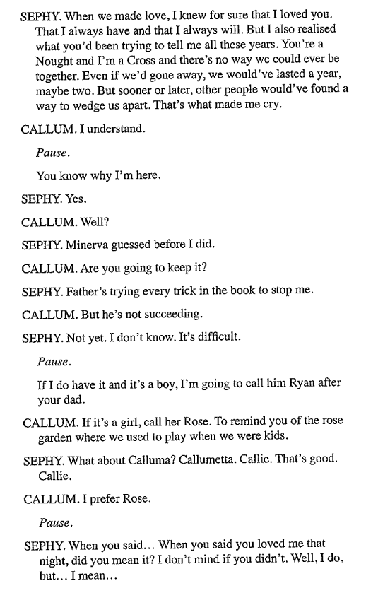
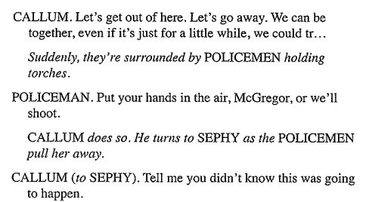
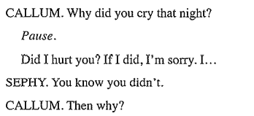
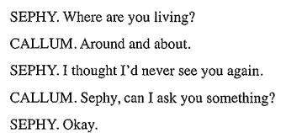
EXTRACT
Act 2, scene 26, pg. 114-116
Please complete this and bring the work with you on Mon 23 March

Section C Theatre Review

Intro – What you saw, what is it about

4 paragraphs of:
Point: What part of the performance are you talking about?.
Evidence : Describe what was done by the actor/director
Explain/Analyse : Discuss the meaning and intention.
Link/Evaluate: link to the question this is often about the impact on the audience

Timing 1 hour 45 mins
Take 5 mins to read through the paper
Section A – 4 mins
Section B 4 marker – 4-6 mins
8 marker – 8-10 mins
12 marker – 12-15 mins
20 marker – 20-25 mins
Section C – 32-40mins
If time, 5 mins to read over answers
Order
Some of you need to do it in chronological order
Most of you need to do the high mark questions first
Sec C - Theatre review, Sec B - 20 marker, 12, 8, 4
Sec A – multiple choice
Good Luck!

