KS4 History Year 9 to year 10 transition work
In Year 10, you will study Early Elizabethan England, 1558-88. This unit explores the challenges faced by Queen Elizabeth I during the first thirty years of her reign and how she responded to them. You will investigate how Elizabeth secured her position as queen, dealt with religious divisions, faced threats from plots and foreign powers, and oversaw a period of exploration, discovery and cultural change.
You will investigate:
- Elizabeth's accession and the challenges she faced in 1558#
- The Religious Settlement and challenges from Catholics and Puritans
Mary, Queen of Scots and the threat she posed to Elizabeth
- Plots, rebellions and the Spanish Armada
- Rivalry with Spain and the outbreak of war
- Education, leisure and theatre in Elizabethan society
- Poverty and the government's response to the poor
- Exploration, voyages of discovery and attempts to establish colonies in Virginia
Exam Information
Unit Title: Option B4: Early Elizabethan England, 1558–88
Exam Length: 1 hours 50 minutes
GCSE Weighting: 40% of the full GCSE
Marks Available: 32 marks - [total paper 64]
This unit is assessed as part of Paper 2: British Depth Study and Period Study, alongside Superpower Relations and the Cold War, 1941–91.

TASK 1: Complete the pre-reading below and highlight key information
Could Elizabeth Keep Her Throne?
Elizabeth's Accession, 1558
When Elizabeth became Queen of England on 17 November 1558, she inherited a country facing a number of serious challenges. Although she was only twenty-five years old, she was expected to solve problems that had built up over many years.
England's government was headed by the monarch, who worked with advisers known as the Privy Council. Elizabeth inherited a government that functioned reasonably well, but there were major concerns about money, religion and security.
One of the biggest problems was England's financial weakness. The country was heavily in debt after expensive wars fought during the reigns of Henry VIII and Mary I. The government did not have enough money and the Crown's income was limited. This meant Elizabeth could not easily afford large armies or expensive foreign wars.
Religion was another major challenge. During the reign of Henry VIII, England had broken away from the Roman Catholic Church. Under Edward VI the country became more Protestant, but Mary I restored Catholicism and attempted to return England to the authority of the Pope. By 1558 England was deeply divided between Catholics and Protestants. Elizabeth needed to find a solution that would avoid further conflict.
Elizabeth also faced threats from abroad. France was England's traditional enemy and was a powerful Catholic country. The French supported Mary, Queen of Scots, who had a strong claim to the English throne. Scotland itself was closely linked to France through an alliance known as the Auld Alliance. Spain was also a powerful Catholic nation whose actions Elizabeth needed to consider carefully.
Elizabeth's legitimacy was another problem. Some Catholics believed she was illegitimate because they did not accept Henry VIII's divorce from Catherine of Aragon. This meant they did not recognise Elizabeth as the rightful queen.
Many people also questioned whether a woman could rule successfully. Sixteenth-century society was dominated by men and most people believed women should obey their fathers or husbands. Elizabeth therefore faced challenges because of her gender.
Finally, Elizabeth was unmarried and had no children. This created uncertainty because there was no clear heir to the throne. Many members of Parliament believed she should marry quickly in order to secure the Tudor dynasty and strengthen England's position.
Despite these difficulties, Elizabeth possessed important strengths. She was highly educated, spoke several languages and was skilled at public speaking. She was cautious, intelligent and determined to maintain her authority. These qualities helped her deal with many of the challenges she faced during the early years of her reign.

TASK 2: Create a "Queen Elizabeth's Report Card".
Give Elizabeth a score out of 10 for each challenge:
Challenge | Score | Reason why?
Money
Religion
Foreign threats
Being a woman
Marriage & heir
TASK 3: Complete the pre-reading below and highlight key information
The Religious Settlement
Solving England's Religious Divisions
Religion was one of the most important issues facing Elizabeth when she became queen. England had experienced dramatic religious change under the previous monarchs.
Henry VIII had broken away from the authority of the Pope and established the monarch as head of the Church of England. Edward VI introduced more Protestant beliefs and practices. Mary I then restored Catholicism and re-established links with Rome. By 1558 many people were confused about what religion England should follow.
Elizabeth wanted to create stability. She understood that forcing people to follow extreme religious beliefs could lead to unrest. In 1559 she introduced the Religious Settlement.
The first part was the Act of Supremacy. This law made Elizabeth Supreme Governor of the Church of England. The title was carefully chosen because some people were uncomfortable with a woman being called "Supreme Head" of the Church.
The second part was the Act of Uniformity. This required churches to use an official Protestant prayer book and made church attendance compulsory. Anyone who failed to attend church could be fined.
The Religious Settlement created a Church of England that was mainly Protestant but still kept some traditional features that Catholics recognised. Elizabeth hoped this would encourage as many people as possible to accept the new system.
The Church of England played an important role in society. Churches were not only places of worship but also centres of community life. Parish priests recorded births, marriages and deaths and often helped poor members of their communities.
Not everyone accepted the settlement. Some Protestants, known as Puritans, believed the Church remained too similar to Catholicism. They wanted further reforms and a simpler form of worship.
Catholics were also unhappy. Some accepted the changes outwardly while continuing to practise Catholic beliefs in private. Others hoped that England would eventually return to Catholicism.
Although the Religious Settlement reduced tensions, religious divisions remained a significant challenge throughout Elizabeth's reign.

TASK 4: Complete the speech bubbles and thought bubbles to say:
- What Elizabeth did with religion in England
- How people reacted to her changes
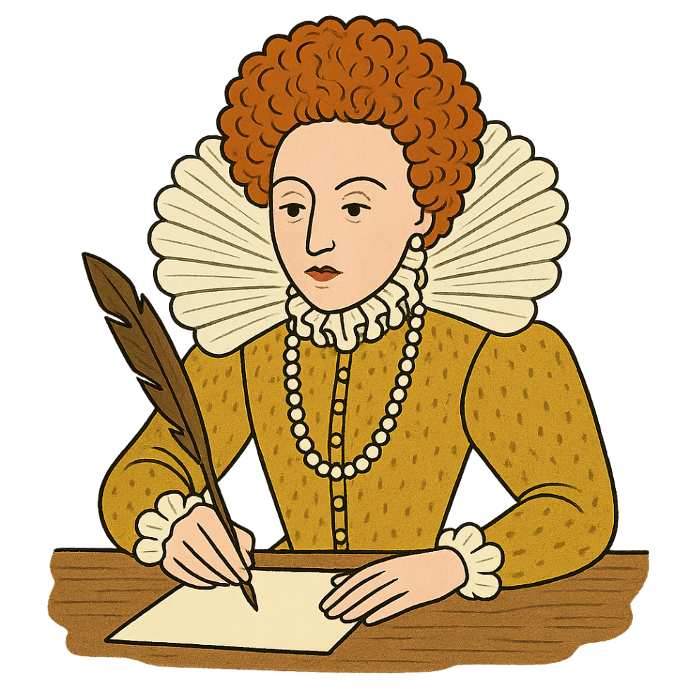
Reaction from the English people:

Elizabeth’s religious settlement:

TASK 5: Complete the pre-reading below and highlight key information
The Spanish Armada
England and Spain: From Friendship to War
At the start of Elizabeth's reign, England and Spain were not enemies. However, relations gradually worsened because of political, religious and commercial rivalry.
Religion played an important role. Elizabeth was Protestant, while King Philip II of Spain was a committed Catholic. Philip believed it was his duty to defend Catholicism across Europe. Political rivalry developed in the Netherlands. The Dutch were fighting against Spanish rule and many were Protestant. Elizabeth provided support to the Dutch rebels. This angered Philip, who viewed English involvement as interference in his empire. Commercial rivalry also increased. English merchants wanted access to valuable trade routes and markets. Spanish ships transported gold and silver from the Americas, making Spain extremely wealthy. Privateering became another source of conflict. English sailors such as Sir Francis Drake attacked Spanish ships and settlements. Although these attacks were technically piracy, Elizabeth often encouraged them because they weakened Spain and brought wealth to England.
In 1587 Drake launched a surprise raid on Cadiz, a Spanish port. He destroyed ships and supplies, delaying Spanish invasion plans. Drake famously described the attack as "Singeing the King of Spain's Beard." Philip eventually decided to invade England. In 1588 he launched the Spanish Armada, a fleet of around 130 ships carrying approximately 8,000 sailors and 19,000 soldiers. The Armada was one of the largest naval forces assembled in Europe at the time and represented Spain's determination to remove Elizabeth from the throne and restore Catholicism to England.
The Spanish plan was to sail through the English Channel, link up with Spanish troops in the Netherlands and then invade England. However, the English fleet, commanded by Lord Howard and supported by experienced sailors such as Drake, had around 200 ships, many of which were smaller, faster and easier to manoeuvre than the larger Spanish vessels. The English fleet used these advantages to attack the Armada. During the Battle of Gravelines, English commanders sent fireships into the Spanish fleet. This caused confusion and forced many Spanish ships to break formation, making them easier targets for English attacks.
Bad weather also played a major role. After failing to defeat the English, the Armada was forced to sail around Scotland and Ireland to return home. Powerful storms damaged many ships and pushed them onto dangerous coastlines. By the end of the campaign, Spain had lost around 50 ships and approximately 15,000 men, many due to storms, disease and shipwrecks rather than direct fighting. English losses were much lower, although disease later claimed the lives of many sailors. The defeat of the Armada became one of the most famous events of Elizabeth's reign. It increased national pride, strengthened Elizabeth's reputation as a successful ruler and demonstrated that England could successfully resist one of the most powerful countries in Europe.
TASK 6: Create a newspaper front page from August 1588:
THE ELIZABETHAN GAZETTE
_____________________________________________________________________________________________________________________________________________________________________________________________________________________________________________________________________________________________________________________________________________________________________________________________________________________________________________________________________________________________________________________________________________________________________________________________________________________________________________________________________________________________________________________________________________________________________________________________________________________________________________________________________________________________________________________________________________________________________________________________________________________________________________________________________________________________________________________________________________________________________________________________________________
_____________________________________________________________________________________________________________________________________________________________________________________________________________________________________________________________________________________________________________________________________________________________________________________________________________________________________________________________________________________________________________________________________________________________________________________________________________________________________________________________________________________________________________________________________________________________________________________________________________________________________________________________________________________________________________________________________________________________________________________________________________________________________________________________________________________________________________________________________________________________________________________________________________

TASK 7: Complete the pre-reading below and highlight key information
Exploration and Virginia
The Age of Exploration and the Virginia Investigation
The Elizabethan period is often known as the Age of Exploration. During this time, European countries sent ships around the world to discover new trade routes, gain wealth and expand their influence. Improvements in shipbuilding and navigation technology made long-distance voyages safer and more practical. Better maps, compasses and sailing techniques allowed sailors to travel further than ever before.
England was eager to compete with powerful countries such as Spain and Portugal, which controlled many profitable trade routes and colonies. English merchants hoped to find new markets where they could sell goods and obtain valuable resources. Exploration was therefore seen as a way to increase England's wealth and power. One of the most famous Elizabethan explorers was Sir Francis Drake. Between 1577 and 1580, he became the first Englishman to circumnavigate the globe. His voyage brought valuable treasure back to England and demonstrated England's growing naval strength. Another important figure was Sir Walter Raleigh, who promoted plans to establish an English colony in North America. This colony was named Virginia after Elizabeth I, who was often known as the Virgin Queen. Elizabeth hoped that successful colonies would increase England's influence overseas and challenge Spanish power in the Americas.
However, the first Virginia settlement was not a success. Historians have identified several key reasons for its failure:
Evidence 1: Lack of Food and Supplies- The settlers depended heavily on supplies sent from England. The colony struggled to grow enough food and many settlers were not experienced farmers. When supply ships were delayed, food shortages became a serious problem. As conditions worsened, survival became increasingly difficult.
Evidence 2: Poor Relations with Native Americans- At first, some Native American groups traded with the English settlers. However, relations gradually became more hostile. Competition over land and resources created tension, and cooperation broke down. Without local support, the settlers found it even harder to obtain food and survive.
Evidence 3: Distance from England- Virginia was over 3,500 miles from England. Communication was extremely slow and messages could take months to arrive. If the settlers needed help, they could not receive immediate support. This meant that problems often became much worse before assistance could reach the colony.
Evidence 4: War with Spain- By the late 1580s, England was increasingly focused on its conflict with Spain. Resources that could have been used to support Virginia were instead needed for defence. The approach of the Spanish Armada in 1588 meant that protecting England became the government's main priority. As a result, the colony received less attention and support.
Although the first Virginia settlement failed, it was still important. These early attempts taught the English valuable lessons about exploration and colonisation. Future colonies used this experience to improve their chances of success. Virginia therefore helped lay the foundations for England's later colonial empire and expansion across the world.
TASK 8: You are a historian investigating why England's first colony in Virginia failed. Create a case file with evidence of the different reasons why it failed
?
TASK 9: Complete the pre-reading below and highlight key information
Education, Leisure and Theatre
Everyday Life in Elizabethan England
Elizabethan society was organised into different social classes. Wealthy nobles and gentry enjoyed privileges that poor labourers and servants did not. A person's social position often determined their opportunities in life.
Education became increasingly important during Elizabeth's reign. Wealthy boys could attend grammar schools where they studied subjects such as Latin, Greek and religion. Some continued their studies at university. Girls generally received less formal education. Wealthy girls were often taught at home by tutors and learned reading, writing, music and household management. Poor girls usually received little formal education. Most poor children were expected to work from an early age. Many became apprentices, learning trades such as blacksmithing, weaving or carpentry.
Leisure activities varied according to social class. Popular sports included football, archery, tennis, bowling and hunting. Public celebrations, fairs and festivals were also important parts of community life. The theatre became one of the most popular forms of entertainment. Purpose-built theatres appeared in towns and cities, particularly London. The Theatre, built in 1576, was one of the first permanent theatres in England. People from all social classes attended performances. Wealthy spectators could sit in galleries, while poorer people stood in front of the stage. William Shakespeare began his career during Elizabeth's reign and became one of England's most famous playwrights. His plays attracted large audiences and explored themes such as power, ambition, loyalty and love. Not everyone approved of the theatre. Puritans believed it encouraged bad behaviour, crime and disorder. Some argued that people should spend more time working or worshipping instead of attending performances.
Despite these criticisms, theatre continued to grow in popularity and became one of the defining features of Elizabethan society. It reflected the increasing prosperity, confidence and cultural development of England during the late sixteenth century.

TASK 10: Complete the speech bubbles below for the following types of people:
- A wealthy boy attending a grammar school.
- A wealthy girl educated at home.
- A poor apprentice learning a trade.
- A visitor attending a theatre performance in London.

3-

4-

1-

2-

