Transition Work for GCSE Media Studies
Year 10 into year 11

Task 1 — Crime Drama Genre Foundations
Goal:
Refresh and deepen understanding of genre, conventions, and narrative before studying Trigger Point and The Sweeney.
Research the crime drama genre and complete the following:
- Define the crime drama genre in your own words.
- Identify five common conventions of crime dramas.
  - Convention 1
  - Convention 2
  - Convention 3
  - Convention 4
  - Convention 5
- Explain how crime dramas typically use:
  - Character types
  - Narrative structure
  - Setting
Give an example of a crime drama you’ve watched and explain how it fits the genre.

Task 2 — Comparing Crime Dramas (Trigger Point vs The Sweeney)
Goal:
Prepare for the comparative analysis required in Component 2.
Instructions:
Watch clips or trailers from both shows (no need to watch full episodes yet).

Complete the table:

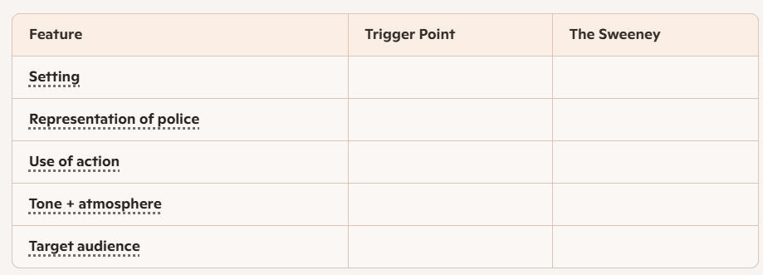

Task 3 — Music Video Context Research
Goal:
Build contextual knowledge for the three set texts.

Instructions:
Research each artist and complete the prompts.
Taylor Swift
- What genre(s) is she associated with?
- What themes appear in her music?
- What is her typical target audience?
Stormzy
- What genre(s) is he associated with?
- What social or political themes appear in his work?
- Who is his target audience?
TLC
- What era did they rise to fame in?
- What issues do their videos often address?
- Who was their audience?
Task 4 — Music Video Media Language Analysis
Goal:
Refresh Component 1 skills and apply them to music videos.
Choose one of the following:
- Taylor Swift
- Stormzy
- TLC
Then complete:
- Identify three key shots used in the video.
  - Shot 1
  - Shot 2
  - Shot 3
- Explain how colour, lighting, or editing creates meaning.
- Describe how the artist is represented. Use terms like: stereotype, empowerment, vulnerability, rebellion.
- Explain how the video appeals to its target audience.

Task 5 — Representation Across Crime Drama & Music Videos
Goal:
Prepare for cross-media representation analysis.
Instructions:
Choose one representation from the list:
- Gender
- Ethnicity
- Authority
- Youth
- Masculinity

Then:
- Explain how this group is represented in crime dramas.
- Explain how this group is represented in music videos.
- Identify one similarity and one difference.

Task 6 — Exam-Style Practice Question

Introduce the style of extended responses in Component 2.

Question: “How does media language create meaning in one crime drama you have studied?”
Write one paragraph using:
- Camera work
- Mise-en-scène
- Sound
- Editing

