


Name | _______________________________________________________
Form | _______________________________________________________
Science teacher | _______________________________________________________
Due date | September 2026

Complete this booklet over the summer. Bring it to your first Science lesson in Year 10.

How to use this workbook
Purpose
• This transition workbook reviews the GCSE content covered in Year 9 and prepares you for Year 10 OCR Gateway Combined Science A.
• Complete the questions independently first. Use your exercise book, Knowledge Organisers, Kerboodle and Teams resources if you get stuck.
• Your September baseline will check key Year 9 knowledge, maths skills, graph skills and Working Scientifically skills.

Science | Year 9 topics revised in this booklet
Biology | B1 Cell-level systems; B2 Scaling up
Chemistry | C1 Particles; C2 Elements, compounds and mixtures
Physics | P1 Matter; P2 Forces
Working Scientifically | Variables, practical planning, graphs, means, anomalies, accuracy, precision and command words

Student self-check
Topic | Red: I need help | Amber: nearly there | Green: secure
B1 Cell-level systems
B2 Scaling up
C1 Particles
C2 Elements, compounds and mixtures
P1 Matter
P2 Forces
Working Scientifically

Part A: Biology
OCR Gateway Combined Science A: B1 Cell-level systems and B2 Scaling up
Key knowledge to remember
• Animal cells contain a nucleus, cytoplasm, cell membrane, mitochondria and ribosomes. Plant cells also contain a cellulose cell wall, chloroplasts and a permanent vacuole.
• Microscope calculations use: magnification = image size ÷ actual size. Always convert units first.
• Diffusion, osmosis and active transport move substances into and out of cells. Exchange surfaces are thin, have a large surface area and a good blood supply or concentration gradient.
• Respiration releases energy in cells. Photosynthesis stores energy in glucose in plant cells.
• Organs and organ systems are made from specialised cells and tissues working together.

1. The diagram shows an animal cell and a plant cell. Label A-K using the correct cell structures. [11 marks]
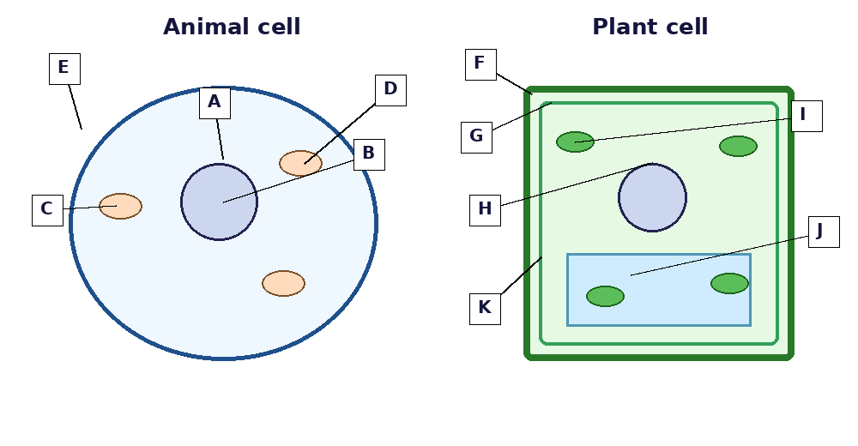
Letter | Cell structure
A
B
C
D
E
F
G
H
I
J
K

2. Complete the table with the correct function of each cell structure. [6 marks]
Cell structure | Function
Nucleus
Mitochondria
Ribosomes
Cell membrane
Chloroplasts
Cell wall
3. A student views a cheek cell using a microscope. The image is 30 mm wide. The actual cell is 60 micrometres wide. Calculate the magnification. Show your working and unit conversion. [4 marks]
_______________________________________________________________________________________________
_______________________________________________________________________________________________
_______________________________________________________________________________________________
_______________________________________________________________________________________________
4. Match each transport process to the correct description, then answer the questions below. [7 marks]
Process | Description letter
Diffusion
Osmosis
Active transport
Letter | Description
A | Movement of water through a partially permeable membrane from dilute to concentrated solution.
B | Movement of particles from a high concentration to a low concentration.
C | Movement of particles against a concentration gradient using energy from respiration.

5. Complete the word equations. [6 marks]
Process | Word equation
Aerobic respiration | glucose + __________ → carbon dioxide + __________
Photosynthesis | carbon dioxide + __________ → glucose + __________

6. Explain how the circulatory system helps substances move around the body. Include the heart, blood vessels and blood in your answer. [6 marks]

Part B: Chemistry
OCR Gateway Combined Science A: C1 Particles and C2 Elements, compounds and mixtures
Key knowledge to remember
• All substances are made of particles. The arrangement and movement of particles explain solids, liquids and gases.
• Atoms contain protons and neutrons in the nucleus with electrons arranged in shells around the nucleus.
• Atomic number = number of protons. Mass number = protons + neutrons.
• An element contains one type of atom. A compound contains two or more elements chemically bonded. A mixture is not chemically bonded and can be separated physically.
• Separation methods include filtration, crystallisation, distillation and chromatography.

7. The diagrams show the particle arrangements in three states of matter. Identify A, B and C and describe the particle movement in each state. [6 marks]
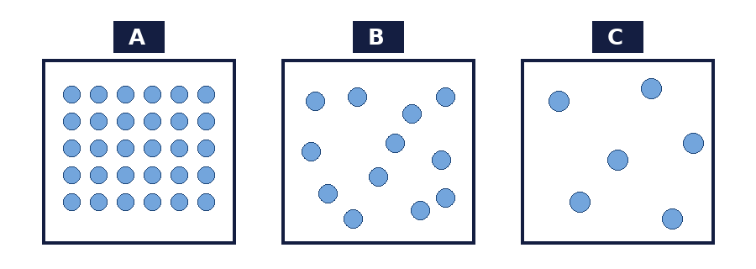
Diagram | State | Particle movement
A
B
C

8. Label the atom diagram and complete the subatomic particle table. [8 marks]
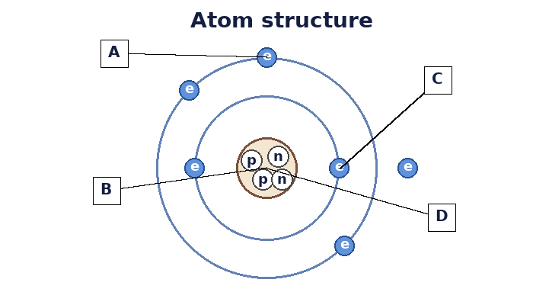
Particle | Relative charge | Relative mass | Where found
Proton
Neutron
Electron

9. Complete the table for each atom. Assume each atom is neutral. [8 marks]
Atom | Atomic number | Mass number | Protons | Neutrons | Electrons
Carbon-12 | 6 | 12
Sodium-23 | 11 | 23
Chlorine-35 | 17 | 35
Oxygen-16 | 8 | 16

10. Define element, compound and mixture. Give one example of each. [6 marks]
Term | Definition | Example
Element
Compound
Mixture

11. Use the separation methods diagram. For each mixture, choose the best separation method and explain why. [6 marks]

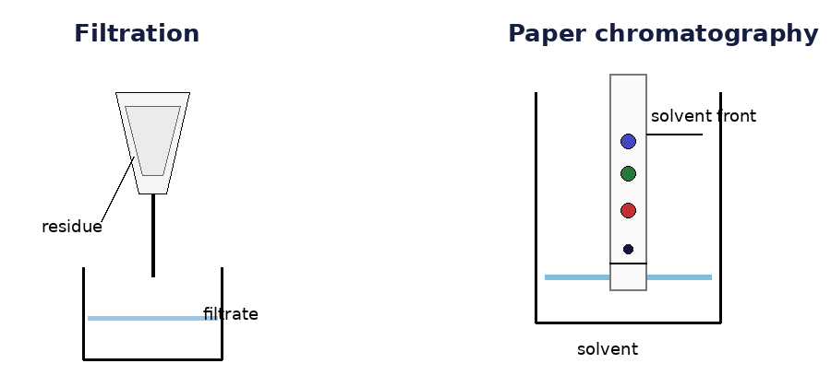

Mixture | Best method | Why?
Sand and water
A coloured dye mixture
Salt dissolved in water

12. Balance the equations and explain why mass is conserved in chemical reactions. [6 marks]
Equation | Balanced equation
Mg + O2 → MgO
Na + Cl2 → NaCl
H2 + O2 → H2O

Part C: Physics
OCR Gateway Combined Science A: P1 Matter and P2 Forces
Key knowledge to remember
• Density = mass ÷ volume. Use kg/m³ or g/cm³ depending on the question.
• Heating changes internal energy. Specific heat capacity is the energy needed to raise 1 kg of a substance by 1 °C.
• A force is a push or pull. Forces are vectors because they have size and direction.
• Resultant force causes acceleration. Newton’s second law is F = m × a.
• Hooke’s law: extension is proportional to force up to the limit of proportionality.

13. A metal cube has a mass of 540 g and a volume of 200 cm³. Calculate its density. [3 marks]
_______________________________________________________________________________________________
_______________________________________________________________________________________________
_______________________________________________________________________________________________
14. A 2.0 kg block is heated from 20 °C to 45 °C. The specific heat capacity of the block is 420 J/kg °C. Calculate the energy transferred. [4 marks]
_______________________________________________________________________________________________
_______________________________________________________________________________________________
_______________________________________________________________________________________________
_______________________________________________________________________________________________
15. The force diagrams show three objects. Calculate the resultant force and state the motion for A, B and C. [9 marks]
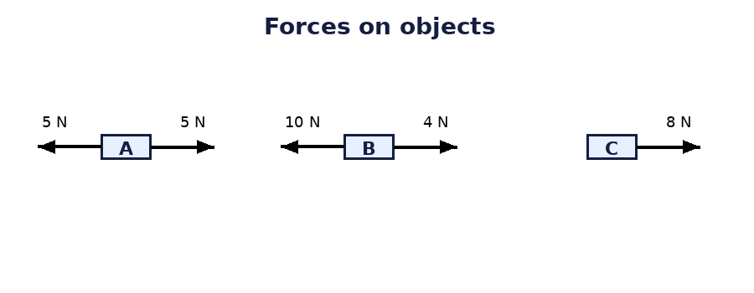
Object | Resultant force | Direction | Motion
A
B
C

16. The graph shows the velocity of a car over 10 seconds. Answer the questions below. [8 marks]
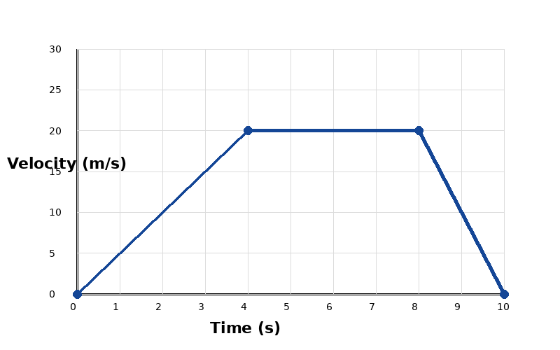
Question | Answer
a) Calculate the acceleration from 0-4 s.
b) Describe the motion from 4-8 s.
c) Calculate the deceleration from 8-10 s.
d) Calculate the distance travelled in the first 4 s.

17. A 0.80 kg ball accelerates at 6.0 m/s². Calculate the resultant force on the ball. Then calculate its weight on Earth where g = 10 N/kg. [5 marks]
_______________________________________________________________________________________________
_______________________________________________________________________________________________
_______________________________________________________________________________________________
_______________________________________________________________________________________________

18. A spring extends by 0.020 m when a force of 4.0 N is applied. Calculate the spring constant. Then calculate the elastic energy stored. [6 marks]
_______________________________________________________________________________________________
_______________________________________________________________________________________________
_______________________________________________________________________________________________
_______________________________________________________________________________________________
_______________________________________________________________________________________

Part D: Working Scientifically and maths skills
Key knowledge to remember
• Independent variable: the variable you change. Dependent variable: the variable you measure. Control variables: variables kept the same.
• A valid practical changes only one independent variable and controls the others.
• Repeat readings help identify anomalies and calculate a reliable mean.
• Accuracy means close to the true value. Precision means repeat readings are close together. Resolution is the smallest change a measuring instrument can detect.
• For calculations, show equation, substitution, answer and unit.

19. A student investigates how force affects the extension of a spring. Identify the variables and write a short method. [9 marks]
Variable type | Variable
Independent variable
Dependent variable
Control variable 1
Control variable 2

20. The student collects the results below. Calculate the mean extension for each force. Circle any anomalous result. [8 marks]
Force (N) | Extension 1 (cm) | Extension 2 (cm) | Extension 3 (cm) | Mean (cm)
0 | 0.0 | 0.0 | 0.0
1 | 2.1 | 2.0 | 2.0
2 | 4.0 | 4.1 | 4.2
3 | 6.1 | 9.5 | 6.0
4 | 8.0 | 8.1 | 8.0

21. Plot a graph of mean extension against force. Add a line of best fit and describe the relationship. [4 marks]
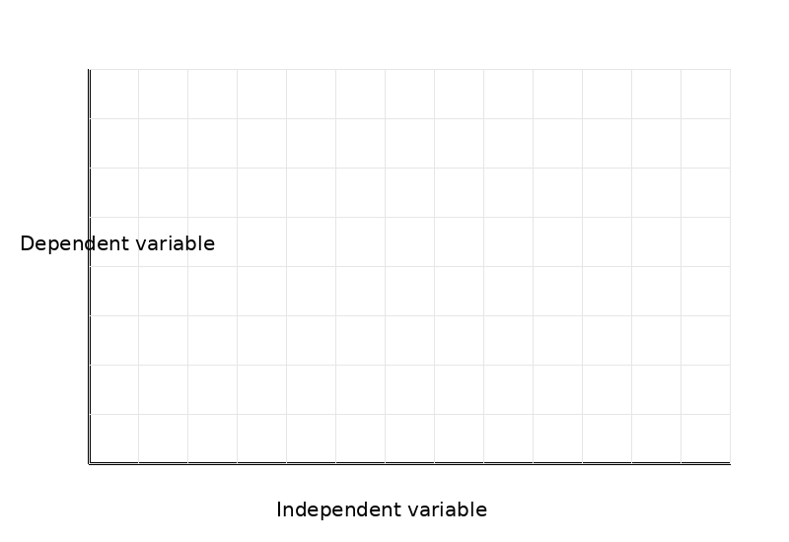
22. Complete the command word table. [5 marks].
Command word | What you need to do
State
Describe
Explain
Calculate
Evaluate

23. Extended response. Explain how to find the density of an irregular solid using a balance and measuring cylinder. Include equipment, measurements, calculation and how to improve accuracy. [6 marks]

Final student checklist
Task | Tick when complete
I completed all Biology questions.
I completed all Chemistry questions.
I completed all Physics questions.
I completed the Working Scientifically section.
I checked my calculations include working and units.
I used green pen to correct answers after checking the answer booklet.
I wrote down three topics I need to revise before the baseline.

My three priority topics for September
- _______________________________________________________________________________________________
- _______________________________________________________________________________________________
- _______________________________________________________________________________________________

