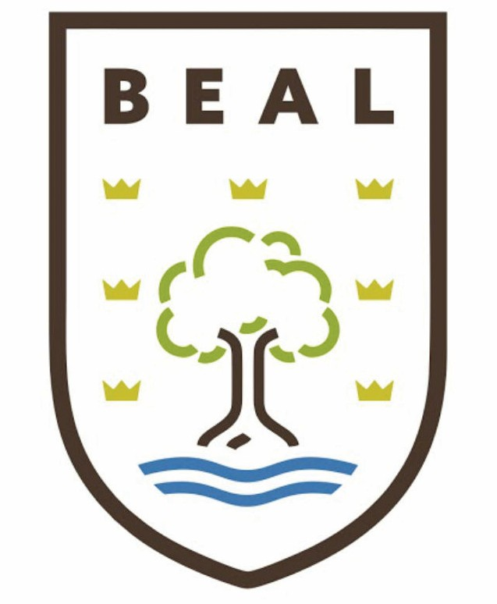

Department of Economics
Year 9 → Year 10 GCSE Economics (AQA)
Summer Bridging Work
Name: ________________________
Welcome to Your GCSE Economics Summer Bridging Workbook
As you prepare to begin GCSE Economics (AQA), this booklet has been designed to introduce you to some of the exciting topics you will study in Year 10.
Economics helps us understand the world around us. Every day, people make choices about how to spend money, businesses decide what to produce, and governments make decisions that affect jobs, prices and living standards. Throughout this workbook, you will explore how markets work, investigate real-world economic issues, practise important mathematical skills and develop the research and analytical skills needed for GCSE success. 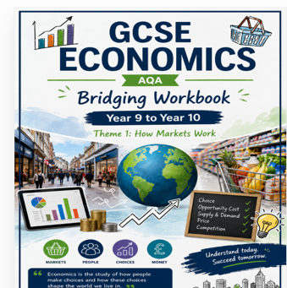

Contents
Task 1. What is a Market?
Task 2 – Market Research
Task 3– Supply and Demand Reading
Task 4 – Data & Quantitative Skills
Task 5 – Case Study
Task 6 – Research Challenge
Task 7 – Creative Task
GCSE Command Words
Reflection

1. What is a Market?
____________________________________________________________________________________________________________________________________________________________________________________________________________
Write 5 examples of the markets
For example: Supermarkets. Give the names. What do they sell? Who are the buyers? What do they supply and demand?.

Task 1 – Market Research
Choose ONE product (e.g. chocolate, trainers or a mobile phone). Visit three websites and complete a table with price, brand and reason for differences. Then explain why prices vary.

Task 2 – Reading
https://www.bbc.co.uk/news/articles/cyv0qpn9zvjo
Read a BBC News article about food prices or inflation. Answer:
• What happened?
• Which products changed in price?
• Why?
• Was supply or demand affected?
• Who benefits? Who loses?

Task 3 – Quantitative Skills
- A shop sells 500 bottles of water each week.
Week 1: £1.20
Week 2: £1.00
Week 3: £0.80
Calculate:
1. Percentage decrease from Week 1 to Week 3.
2. Revenue each week if 500 bottles are sold.
3. Which week earns the most revenue?
Extension:
A café increases price from £2.50 to £2.80. Calculate the percentage increase.

These changes would make it much more GCSE-style. Here's what I'd replace the tasks with.

- Reading a Graph
The graph below shows the price of oranges over six months.
Month | Jan | Feb | Mar | Apr | May | Jun
Price (£) | 1.20 | 1.10 | 1.30 | 1.50 | 1.40 | 1.60
Students should draw a line graph.
Then answer:
- In which month was the price highest?
- Between which two months did the largest increase occur?
- Calculate the overall percentage increase from January to June.
- Suggest one reason why prices may have increased.
3. Averages
A supermarket sold the following number of loaves of bread.
Monday | Tuesday | Wednesday | Thursday | Friday
180 | 220 | 210 | 250 | 240
Calculate:
- Total sales
- Mean average
- Range
- Explain why supermarkets may monitor average daily sales.

4. Ratios
A fruit shop sells:
- Apples = 120
- Pears = 80
- Write the ratio Apples : Pears.
- Simplify the ratio.
- What fraction of the fruit sold were pears?
- Express this as a percentage.

- Percentages
A bicycle originally costs £420.
It is reduced by 15%.
- Calculate the discount.
- Calculate the new selling price.
Later the price increases by 8%.
- Calculate the final selling price.

- Interpreting Data
A café records customer numbers.
Week | Customers
1 | 420
2 | 470
3 | 520
4 | 490
Answer:
- Which week was busiest?
- Calculate the average.
- Calculate the percentage increase from Week 1 to Week 3.
- Suggest one reason customer numbers may have changed

Task 4 – Case Study
Case Study:
Why Did Chocolate Become More Expensive?
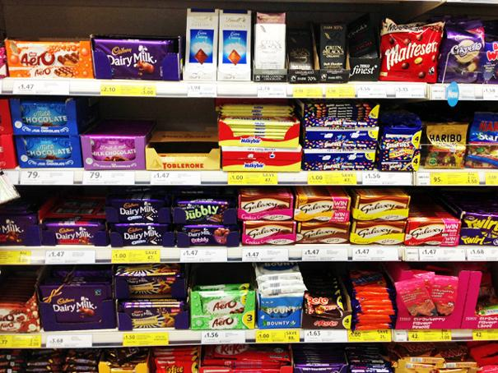
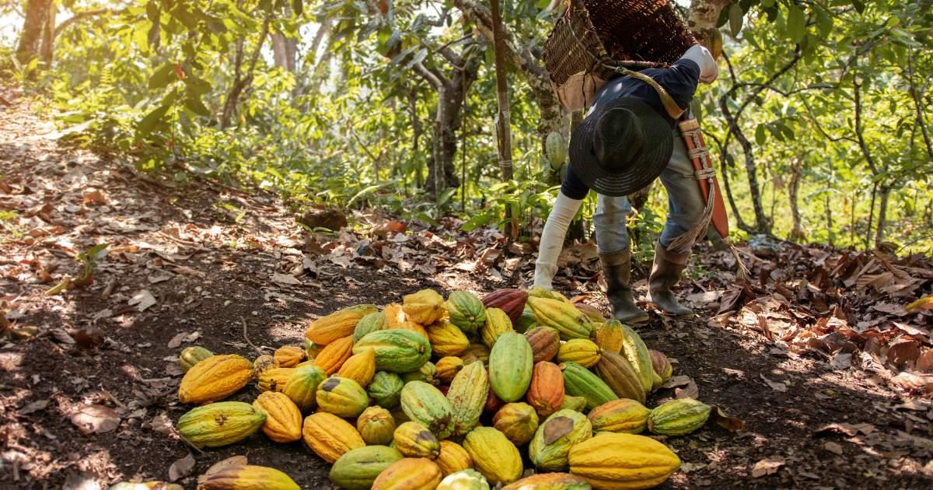
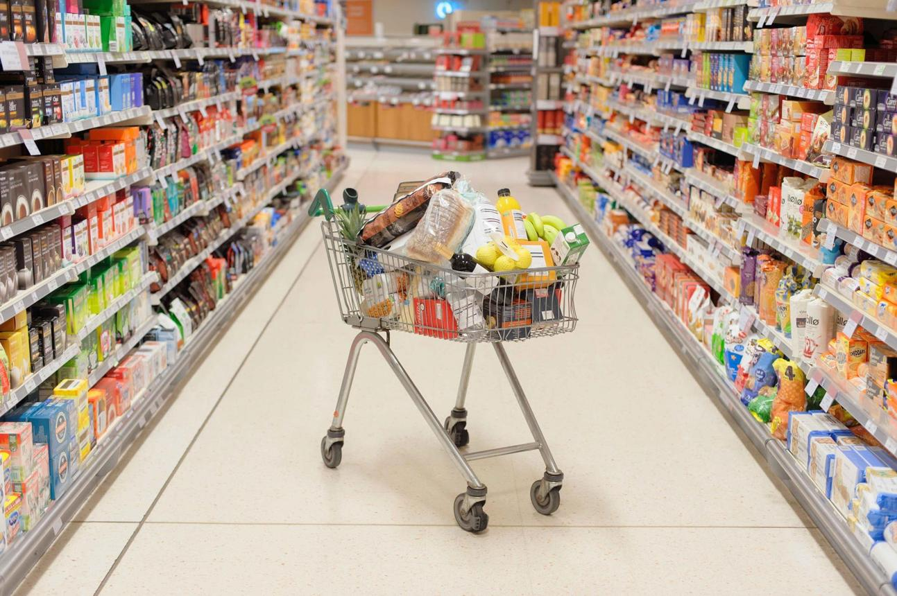

In 2025–26, chocolate prices increased across many UK supermarkets. One reason was that poor weather in West Africa reduced cocoa harvests. Cocoa is the main ingredient used to make chocolate.
With fewer cocoa beans available, manufacturers had to pay more for their ingredients. Many businesses passed these higher costs on to customers by increasing prices. Some shoppers continued buying chocolate, while others switched to cheaper brands or bought less.
Economists explain this using supply and demand. When supply falls but demand stays similar, prices usually rise.
Questions:
1. Define supply.
2. Why did prices increase?
3. Which curve shifted?
4. Draw and label a supply and demand diagram.
5. Explain why some consumers switched products.

Task 5 – Research
Choose ONE of the following investigations.
Option 1 – Why are food prices changing?
Read:
- BBC News Business
- Office for National Statistics – Inflation
Option2 - Why are electric cars becoming cheaper?
Read:
- Autocar News
- Auto Trader News
Present your findings
Produce one A4 page including:
- A title
- At least three facts
- A 150-word explanation
- One paragraph explaining how supply and demand affects the market
- Your own conclusion

Task 6 – Creative
Design an infographic titled 'How Markets Work' including key words: demand, supply, equilibrium, competition, consumers, producers, price.

Reflection
What have you learned? Which task challenged you most? What do you want to learn in GCSE Economics?

